

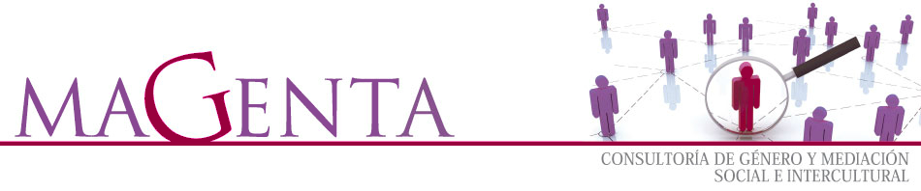
report on preparatory seminar
leonardo da vinci-toi project
mutual assistance
august 2012
REPORT
INTRODUCTION
Mutual assistance in the fields of education and social inclusion are the keys to Bhagavat Educational Trust (BET) philosophy. In line with these principles, BET became the official partner to the Prince’s Trust in Bulgaria in 2004, hosting the mobility project ‘Living and Learning Abroad’. Thanks to the efforts of both organizations, a group of UK people at risk of social exclusion were given the chance to help children in Bulgarian orphanages.
Magenta Consultancy has had a partner role in this project researching and analysing needs in the Principality of Asturias (Spain), adapting educational activities, testing products and disseminating and raising awareness of the project among regional and national contacts. Thus Magenta has organized a seminar with youngsters at social risk in order to promote their social integration, their working skills and their future participation in the mobility project.

GENERAL OBJECTIVE
- Hold a preparatory seminar in the framework of the TOI Mutual Assistance Project so as to find potential participants for the project.

SPECIFIC OBJECTIVES
- Reflect on personal development and improve personal skills, abilities and behaviors.
- Produce an accurate and professionally presented CV.
- Explain Europass documents and draw up a Europass CV and Language Passport.
- Develop skills to take part in an interview.
- Learn basic concept about Bulgarian language and culture.

CONTENTS
The contents of the seminar have been structured from a general approach in the personal skills of the students to a closer insight on their abilities to carry out a job interview in the current labor market. The first stages of the course have focused on identifying, taking responsibility and developing their personal skills. Thus they have worked in a number of activities whereby they have recognized their strengths and weaknesses, reflected on what their real opportunities for working are and established their priorities and professional objectives.
The second and third units of the seminar have concentrated on a general explanation of CV writing. Europass CV documentation and instructions have been specially brought into focus. In unit four students have developed their skills to deal with interviews, including travelling and taking part in a mock and a real interview.
Finally the last stages of the seminar have dealt with Bulgarian culture and language in order to get attendants to know the basics of this country and get closer to the reality of one of the countries participant in the TOI project Mutual Assistance.

OUTCOMES
The learning outcomes of the seminar are as follows:
- Describe a personal strength, identify areas for self-development and describe a personal skill they need to develop.
- Work towards a suitable target, identifying the support and resources needed.
- Develop the agreed skill.
- State their personal details on a CV.
- Outline their work history and personal experience.
- Understand what a referee is.
- Write an accurate CV.
- Make a Europass CV and a Europass Language Passport.
- Organize and take part in an interview, communicating and using body language appropriately.
- Use courtesy expressions in Bulgarian.
- Know basic elements in Bulgarian culture.

ASSESSMENT RESULTS
The assessment has been conducted through a questionnaire students have filled at the end of the seminar. Questions in the form have been outlined in order to get information about students’ personal skills and their level of satisfaction with the course:
- Name your strengths.
- Choose an animal you identify with.
- Describe the project activities you would like to take part in.
- Have you ever heard about a similar project or program?
- Have you heard about Europass before attending the seminar? Did you get to know it through any person or organization?
- In your opinion what is the most interesting Europass document?
- How do you say “Hello” and “Thanks” in Bulgarian?
- Would you like to get to know another culture and language? Why?
- What is your opinion on travelling and helping other groups of people?
- Has this seminar been useful for you?
- What would you stress of the contents learnt in the seminar?
- Could you define ‘Mutual Assistance’?
- What have been the most and least interesting topics of the seminar?
- Why would you take part in a project like this?

Most students have answered that they consider themselves to be nice kind people that like help others and are looking forward to find a job. Some of them define themselves as hardworking.
As regards the questions related to the project, they all match the answer that they would like to travel and help people in another country. Cooking, language and Bulgarian culture are some of the other interests of the attendants. All but one have answered in an affirmative way to the possibility of taking part in the project in the future.
Concerning the project and Europass documents, none of them were familiar with them. They agree that the most interesting ones are the CV and the Language Passport.
In connection with their command on Bulgarian language and definition of ‘Mutual Assistance’ all attendants but one have answered correctly to the questions. Many of them outline language as one of the most useful contents of the seminar, together with Europass CV and interview coaching.
Answers related to level of satisfaction with the seminar show that all the participants have found the contents very interesting and have practiced useful skills for taking part in an interview.

